Doncaster Triathlon Club 
Privacy Notice

Doncaster Triathlon Club (DTC) is committed to safeguarding the privacy of our members, coaches, committee members, competitors and website visitors.
Under European Union law, General Data Protection Regulation (GDPR) will be effective on Friday, 25th May 2018 and DTC will be deemed the “Data Controller” for triathlon-related transactions and activities in relation to personal data.
Depending on your relationship with DTC, data collection and use will vary. Whilst the privacy rights under GDPR do not differ between DTC members, competitors and website visitors, more personal data is collected about DTC members which therefore requires a fully comprehensive privacy policy outlined below.
When you register as a DTC member, by payment of the annual fee and subscription to Rider HQ, you provide consent for the DTC Executive Committee to use your personal information so that they have opportunity to provide you with the best possible triathlon club experience. Access to your personal information is restricted to designated DTC Executive Committee members with specific data needs to monitor, manage and develop the club in accordance with the DTC strategy.

What information do we collect?
We may collect, store and use the following type of personal data that you knowingly provide us with by completing DTC membership or organised competition/event applications which include, but may not be limited to:
- Information that you provide to us when registering with the club;
  - Personal demographic (name, date of birth, address, email and telephone contact(s) information, health information)
- Information that you provide to us when entering a club organised competition;
  - Personal demographic (as above) and in case of emergency (ICE) details
- Information about your computer and about your visits to our website;
  - IP address, geographical location, browser type, operating system, length of visit, website pages visited
- Information provided to us for the payment of club fees;
  - Bank account details
- Any other information that you choose to send to us

Use of cookies
A cookie consists of information sent by a web server to a web browser and stored by the browser. The information is then sent back to the server each time the browser requests a page from the server. This enables the web server to identify and track the web browser.
Session cookies are used to keep track of you whilst you navigate the website and will be deleted when you close your browser.
Persistent cookies enable our website to recognise you when you visit; these will remain stored on your computer until deleted.
Most browsers allow you to reject cookies, however this may have a negative effect on the usability of the website.

Using your personal information
We may use your personal information to:
- Process your club membership fees
- Send you information relating to club meetings
- Send you information about the club or club activities that we think you may be interested in
- Obtain medical assistance should the need arise during training or competitions
- Respond to queries received via our website
- Process competition or event results

Disclosing your personal information
We may disclose information about you insofar as it is reasonably necessary for DTC to undertake its activities and meet our legal obligations. No information is shared with any third party unless explicitly agreed in advance by the DTC member(s).

Security of your personal information
We take the security of personal information extremely seriously. All members’ information is held securely on the RiderHQ management system, accessed via their website (www.riderhq.com), that every member register/create a personal account.
RiderHQ have issued an email to the DTC administrators of RiderHQ which sets out the steps that everyone must undertake to update personal preferences for their accounts, which includes DTC subscriptions and managing their sports-related event entries. These are available in Appendix 1 -RiderHQ. Designated DTC Executive Committee Members have limited administration access to RiderHQ to monitor and report on club membership and manage an emailing list to alert DTC members with important information, such as this data privacy notice.
There are other sport-related associations that DTC members have access to which include British Triathlon, England Athletics and British Cycling. The personal data that they collect from our DTC members is privilege information obtained via members personal accounts which is not shared with DTC Executive Committee.
Similarly, DTC Executive Committee does not share any personal data with the fore mentioned sport-related associations or any other third party.
Minutes of open club meetings, held on a quarterly basis, are made available on the DTC Members’ Facebook page within 14 days. These will note who attended the meeting and refer to any proposals put forward and/or actions agreed by DTC club members.
DTC Executive Committee meets every month; the minutes are documented and retained in a cloud-based information system “Dropbox”. Data access is facilitated to DTC Executive Committee members by unique log ins and passwords and will not be shared outside the DTC Executive Committee.

Retention of your information
The retention period for your personal data will be dependent on the reason it was collected and are summarised as follows:
- Current membership information - for the duration of your DTC membership
- Expired membership information - deleted within six months following your decision to leave DTC
- Organised event/competition – deleted within three months of the event/competition

Your rights
You have the right to be informed about the information we hold about you and the right to request access to this information. Requests will be made formally and in writing to the DTC Secretary, Michael Fells via email; mick.fells@blueyonder.co.uk.
You have the right to have incorrect information rectified.
You have the right to request the information we hold about you is erased.
You have the right to object in the use of your information and the right to restrict how your information is processed.
Any complaints or concerns regarding data privacy must be formally written and directed to the DTC Secretary via email; mick.fells@blueyonder.co.uk or by post; 1 St. Andrews Close, Bessacarr, Doncaster DN4 6SW.
A formal acknowledgment and timeframe for any investigation will be provided to the complainant within 7 days via email or post, whichever is the preferred mode of communication.

Further GDPR resources
Information Commissioner’s Office is the UK’s independent authority set up to uphold information rights in the public interest, promoting openness by public bodies and data privacy for individuals. Guidance is continuously being expanded and can be obtained via https://ico.org.uk or telephoning 0303 123 113.
Privacy policies in place for other sporting associations closely linked with DTC can be found in the listed appendices;
- Appendix 1: Rider HQ
- Appendix 2: Other Sporting associations
  - British Triathlon,
  - England Athletics,
  - British Cycling
  - Doncaster Culture & Leisure Trust

Appendix 1: RiderHQ
The safeguarding policy over DTC Member information can be found at www.riderhq.com/guides/privacypolicy
DTC members can determine the type, mode and frequency of information received from Rider HQ via reviewing the settings on their personal account.
For transparency, the following information has been provided to all clubs to support GDPR implementation and will be adopted by DTC for administration purposes and communicating important information to DTC members.

Opt-in mailing list
MAY 2018
Further to our details on GDPR and RiderHQ, some organisers are sending out 'please opt in to continue receiving our newsletter' - type messages.
This is not necessarily required under the GDPR:
"You do not need to automatically refresh all existing consents in preparation for the new law. But the GDPR sets the bar high for consent, so it’s important to check your processes and records to be sure existing consents meet the GDPR standard. If they do there is no need to obtain fresh consent.
Where you have an existing relationship with customers who have purchased goods or services from you it may not be necessary to obtain fresh consent."
Steve Wood, Deputy Commissioner for Policy, ICO (the ICO is the regulatory body who will enforce the GDPR in the UK)
However, if you do want to do this, for you entrants, members, and mailing list subscribers using RiderHQ, here's how:
First, in 'all emails' create a mailing list for opted-in people (contact us if you don't see the 'mailing lists' link on this screen)
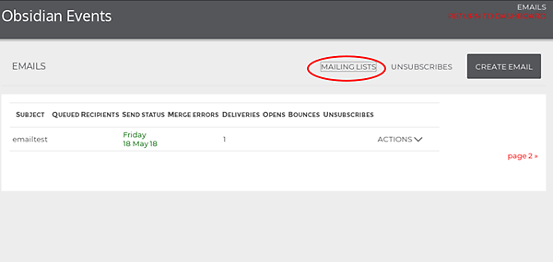
Next, view the mailing list and copy the 'subscribe link' (recipients of your email will use this link to subscribe / opt in to your mailing list)
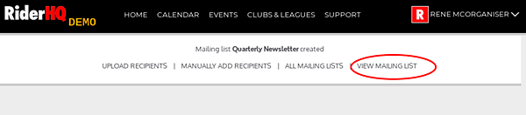
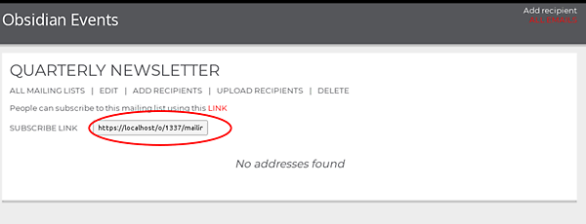
You can either send this out via your own email method (such as MailChimp, etc.) or via a RiderHQ email.
If you send it via RiderHQ you can 'personalise' the link so that the recipient can just click once on the link to 'opt in' without needing to create an account or log in (assuming they already have a RiderHQ account, which they will do if they have entered one of your events or joined your group).
Here's how to send the link through RiderHQ:
First create an email, then add the 'subscribe link' (copied from the mailing list screen in the previous step), using the 'insert link' button (see below)
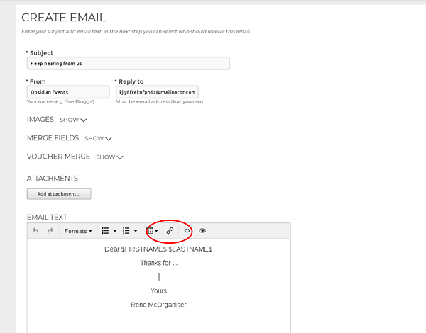
Past the link as the 'Url' and put something encouraging in the text:
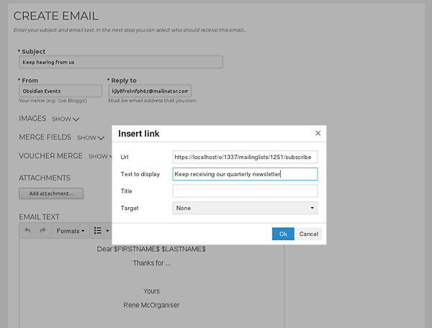
Now, this is important, if you want a one-click opt tick 'track emails' and 'personalise links' at the bottom of the emails screen
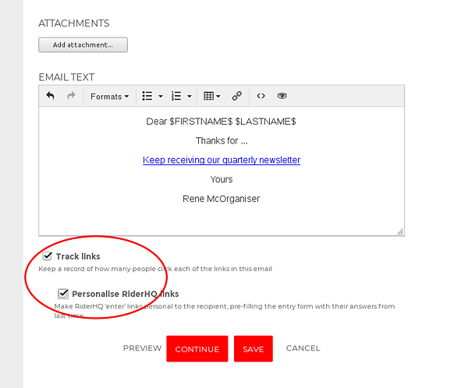
Finally, click 'continue' to add some recipients and then send the email.
Here's what someone clicking (who has an account on RiderHQ) sees:

And here's what you see on your mailing list page:
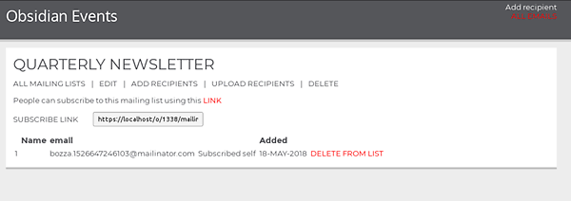

Appendix 2: Privacy policies of other sport-related associations
British Triathlon
www.britishtriathlon.org/about-us/governance/privacy-policy

England Athletics
www.englandathletics.org/Search

British Cycling
www.britishcycling.org.uk/privacynotice

Doncaster Culture & Leisure Trust (DCLT)
www.dclt.co.uk/privacy-policy

